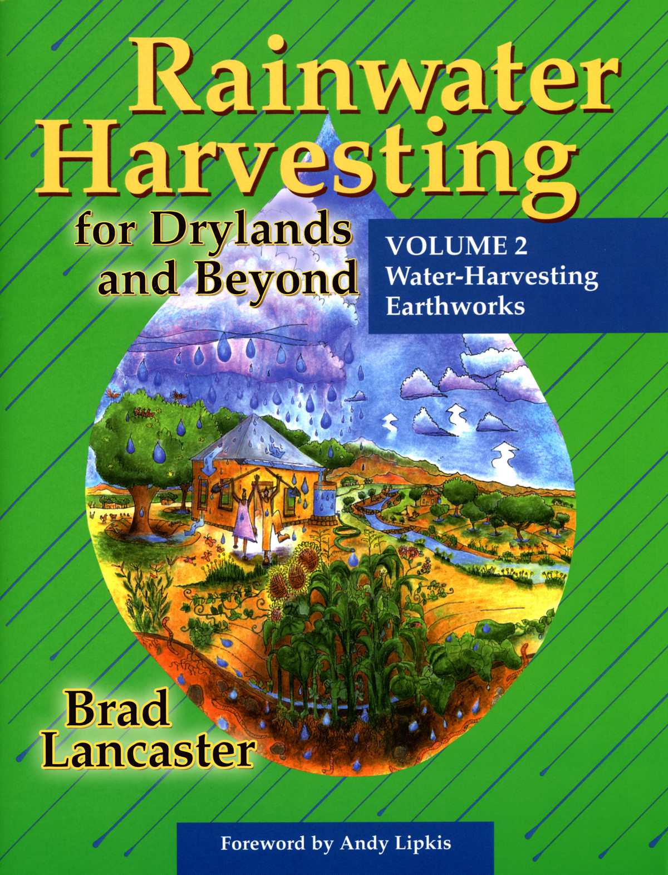
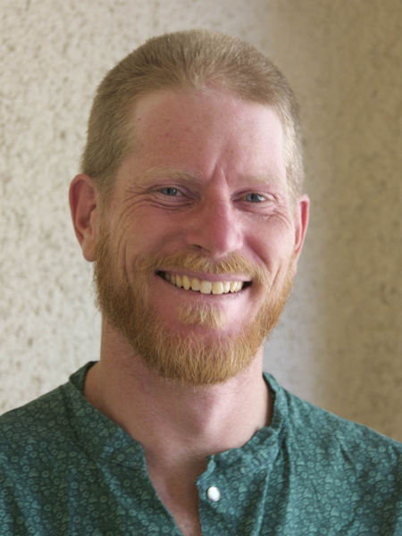
“Turning Water Scarcity
Into Water Abundance”
A Slide Show and Book Signing with
Brad Lancaster

The Ojai Valley Green Coalition welcomes

best-selling author Brad Lancaster

to our Ecology and Community series

Thursday August 28, 2008 • 7:00 pm • $2 donation

Jim MacDonald, a Ventura County top building official, will start the evening with a discussion of the county’s new greywater codes.

Get out your shovels and dance in the rain! That’s what Brad’s book Rainwater Harvesting, Vol. 2 will make you want to do . . . Beyond that, it will:
- Show you how to select, place, size, construct, and plant your chosen water-harvesting earthworks.
- Present detailed how-to information and variations of a diverse array of earthworks, including mulch, vegetation, and greywater recycling, so that you can customize the techniques to your site.
To learn more about Brad Lancaster and his work, visit www.HarvestingRainwater.com.
Join us at the Chaparral Auditorium, 414 E. Ojai Avenue
For more information, visit our website www.OjaiValleyGreenCoalition.org or call (805) 653-8445.

