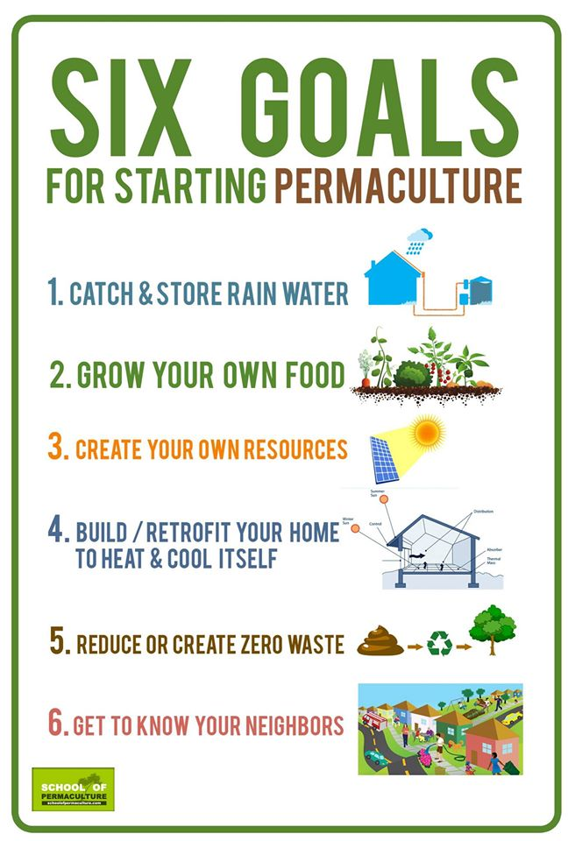
7. Build soil
8. Diversify life
9. Purchase low to no impact materials (meaning looking into how many resources had to be destroyed to make that material and making ethical decisions)
10. Bioremediate toxins
11. ...and the list goes on

