Build tiny home solutions for our homeless women veterans.  Operation WEBS (OPWEBS) has distinguished itself by focusing on its primary objective; build and provide sustainable tiny home on wheels (THOW) solutions for our homeless women Veterans.  Too often after military service, women Veterans struggle with unimaginable difficulties, much like our brothers we served with.  Tragically the burdens of PTSD, loneliness and depression, parenting as a single mother, demons of sexual traumas, and many other challenges associated with both seen or unseen disabilities, magnify the struggles associated with transitioning to civilian life after separating from our military family.  Tiny home communities offer the security, empowerment, solidarity, and hope that many of our Veteran heroines (& heroes) need to be able to transition to civilian normalcies. OPWEBS aims to make available THE FIRST, safe and supportive female Veteran Farming Eco-Village Community of THOWs in Santa Maria Valley, Santa Barbara County, CA. | Operation WEBS  Women Empowered  Build Strong  (OPWEBS)  501(c)(3) Nonprofit Corporation  Sandy Blair  Founder, CEO  P.O. Box 2984  Orcutt, CA 93457  Phone: 805-351-2190  Email: operationwebs@gmail.com  Website: www.operationwebs.org  Visit our website to learn more and to donate to our organization  Fed Tax ID: 83-0935231  A non-partisan, non-political, non-sectarian organization. We do not in any way support any political candidate nor do we endorse any religious organization. The military represents all aspects of the United States of America as does our organization.  Furthermore, links to our website do not represent any endorsements. | Operation WEBS  Women Empowered Build Strong  501(c)(3) Nonprofit Corporation dedicated to assisting women veterans displaced/facing homelessness.  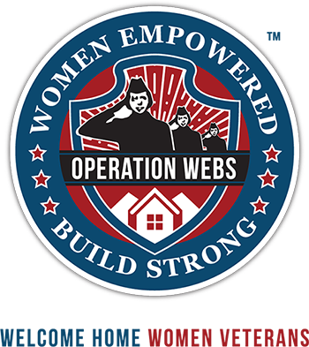  It is my honor to present to you
Operation WEBS: Women Empowered Build Strong
@operationwebs
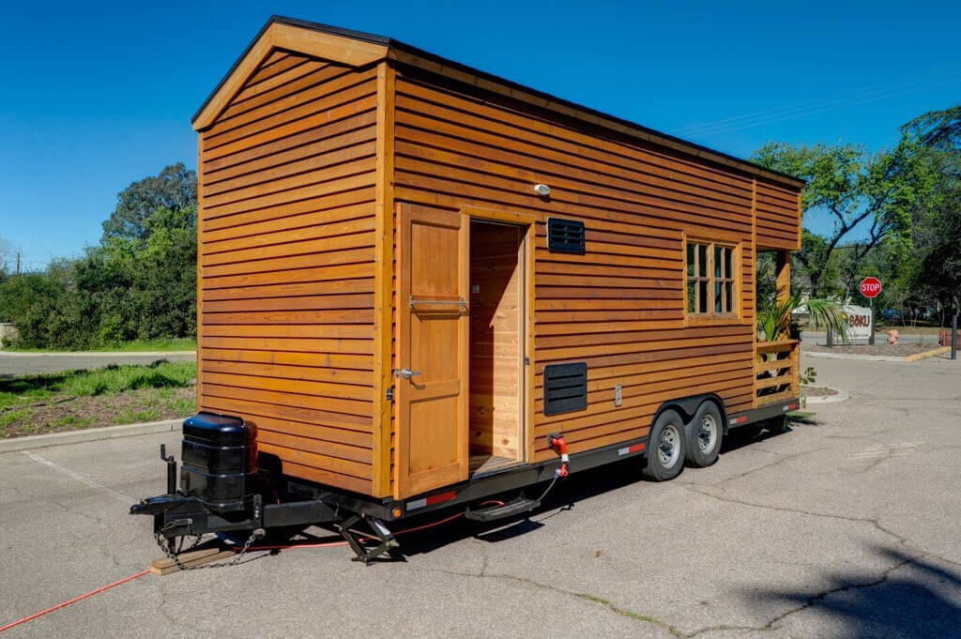 | Items needed for #tinyhouse2019
 | Wood Materials | Windows | Tile | Doors | Paint/Stain
 | Cabinets | Sink | Solar Panels | Skylights | Mini Fridge

#TinyHouse2019

 | Mirrors | Counter Tops | Stove | Compost Toilet | Shower/Tub
OPWEBS builds tiny homes on wheels (THOWs) to provide a safe & stable place for women Veterans who are displaced or homeless after military service. Our vision is to deliver a self-sustaining, eco-friendly, vibrant farming community which offers the empowerment, enrichment, independence, comradery, and security that our Veteran heroines desperately need and deserve to aid in their successful transition to civilian normalcy's after military service.
As an aid in transitioning to civilian life, the goal of our new farming community is to bridge the gap for a large majority of female Veterans experiencing traumas, despair, and financial burdens (to name a few) by offering this sustainable solution to our present-day affordable housing crisis.
We intend to be that bridge to restoring purpose, dignity, and independence once again! THANK YOU for your donations
https://www.guidestar.org OperationWEBS
