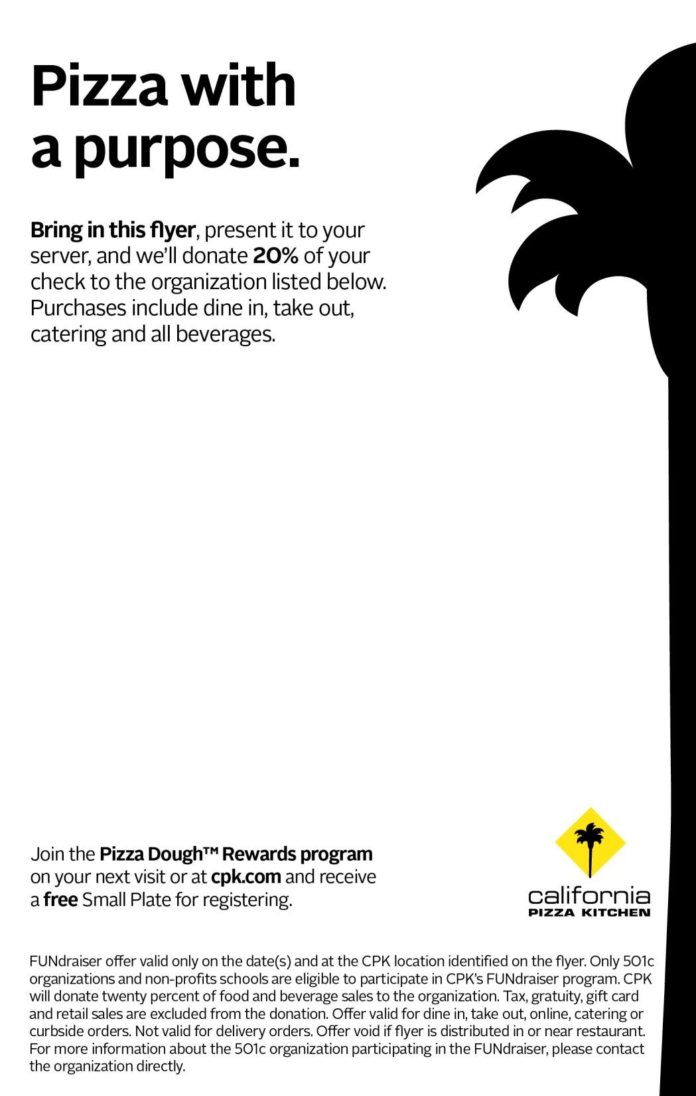

**FUNdraiser**

**in support of:**

**Operation WEBS**

**(**

**Women Empowered Build Strong**

**)**

Sunday, March 17th, 2019

(

All Day

)

**Valid at the following location:**

**California Pizza Kitchen**

876

Marsh St. (next to the movie theater downtown

)

San Luis Obispo, CA

(805) 784

-

0790

